ASTRONOMY 100

Unit 3 Homework

1. What are the phases of the Moon, in order, from one new moon to another?

2. Sketch a waxing gibbous moon. Describe the shape using appropriate terms. Define gibbous and waxing.

Define the following terms:
- eclipse -
- solar eclipse -
- lunar eclipse -
- ecliptic -
- near side of the moon -
- far side of the moon -
- Crescent Moon -
- Quarter Moon -
- Gibbous Moon -
- New Moon -
- Waxing -
- Waning -

Short Answer / Essay Questions:
[The answer must include all relevant information, yet not include a lot of non-relevant information for full credit. Even though you will be referencing various resources, you need to compose your answer primarily in your own words. A completely (or heavily) copied response will also result in a deduction of points. A good rule of thumb would be to attempt to explain the question to a peer who has not taken your astronomy class.]

Answer in AT LEAST 5-7 complete sentences for full credit.
3. Describe the two types of total eclipses and what conditions produce each. You will need to reference phases of the moon in this response. Make sure to describe what an eclipse is and define each type for full credit.

4. Since the Moon passes between the Earth and Sun once a month, and the Earth passes between the moon and Sun once a month, why we don’t have at least two eclipses per month? Make sure to include definitions for full credit and don’t forget to answer WHY. You may include a sketch here to help answer this question (just make sure to explain it).

5. Why do we only ever see one side of the Moon from the Earth? Make sure to identify the proper names for the two sides of the moon and describe the process responsible for this phenomenon (you may need to define that process as well) for full credit.

PART 2
1. How are electric and magnetic fields related?

2. What are the two nature of light models? __________________ & ___________________

3. What is the visible spectrum? Why is it important?

4. What is wave-particle duality?

Use your light presentation and this infographic to help you answer the following questions:
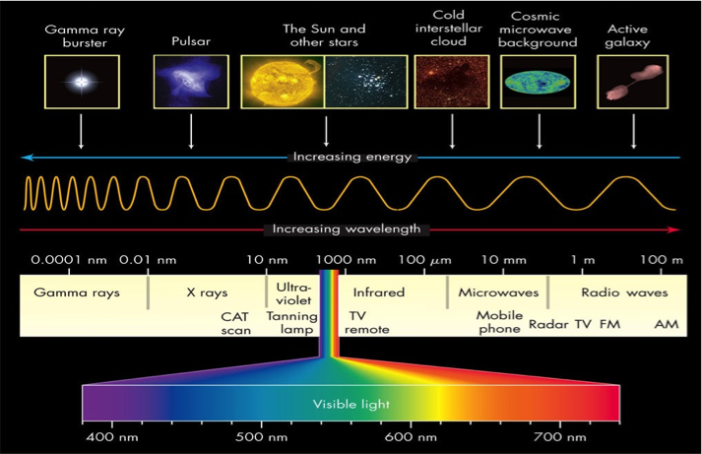
5. List the types of wavelengths on the EM spectrum from lowest (widest) to highest (narrowest) wavelength.

6. List the types of wavelengths on the EM spectrum from lowest (widest) to highest (narrowest)frequency.
7. Are wavelength and frequency directly or inversely related? (direct: they both increase and decrease together; inverse: as one increases, the other decreases)
8. How is energy related to wavelength? (Direct / Inverse). How is energy related to frequency? (Direct / Inverse).
9. What are the three types of spectra & what circumstances produce each?

- _____________________________________________________________

b. ______________________________________________________________

c. ______________________________________________________________
Short Answer / Essay Questions:
[The answer must include all relevant information, yet not include a lot of non-relevant information for full credit. Even though you will be referencing various resources, you need to compose your answer primarily in your own words. A completely (or heavily) copied response will also result in a deduction of points. A good rule of thumb would be to attempt to explain the question to a peer who has not taken your astronomy class.]

Answer in AT LEAST 5-7 complete sentences for full credit.
10. Why do we rely on light to observe the universe? Make sure to define light, and give a relevant reason why we rely on it for full credit.

11. How could we use the doppler effect to inform us of an impending asteroid collision with the Earth? Make sure to include definitions and answer the specific question regarding an IMPENDING collision.

Define the following terms:
- Light -
- Photon -
- Reflection -
- Refraction -
- visible spectrum -
- Doppler shift -
- Redshift -
- Blueshift -
- Wavelength -
- electromagnetic (EM) spectrum -
- spectroscopy -
- continuous spectrum -
- emission line spectrum -
- absorption line spectrum -

